BAYYINAH ART GALLERY

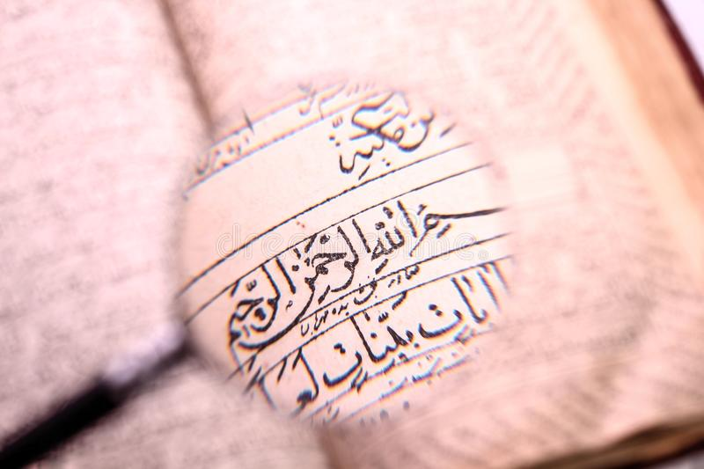

ART PROPOSAL

RAHAT SHAHID
+923344336332

Contents
Artist: 3
Artist Idea: 3
Project Statement: 4
Important feature of Project: 4
Work Sample: 5

 BAYYINAH ART GALLERY PROPOSAL

Artist:

Rahat Shahid
- Rahatshahid@gmail.com
 +923344336332
 www.bayyinahart.com
Since childhood, I have been a keen observer and have always been involved in creative things. The spectrum of my attention was indoor and outdoor decorative and artistic work. After my post-graduation from Punjab University Lahore, being a diehard fan of Sadiquain, I met Mr. Rasheed – Late (NCA Artist) who fine-tuned my calligraphy skills.
Since then visual arts, painting, and calligraphy have always been my area through which I try to elaborate on Quranic verses, Ahadith, and man and his Creator relationship. I believe Art plays an important role in shaping the culture of the society plus in many ways it has a direct relation with the Quran and our religion. That is why as a calligraphic artist I always try my best to create every piece of art which not only appeals to people visually but also carries a message for the society which enables my crafts admirer to get closer to their Creator.

Artist Idea:
The art Islamic calligraphy is a journey where you don’t just learn how to write letters, but you study different aspects of human experience such as Humility, Patience, Self-discipline or manners.
Some people believe that paintings is just a piece of paper with beautiful letters, colors, images etc. They use them decoration purpose only. They don’t know the lesson behind the paintings.
By doing research on the paintings the idea came in to my mind I started my paintings on Islamic calligraphy with unique thought and designs of different Quranic Para’s.

Project Statement:
The project of calligraphy is not just a project but it’s a painting with different lessons that will enlighten the soul. It’s a very unique project.
My calligraphic paintings will give positive impact on human lives. Some of them are listed below:
- Earn good deeds.
- Makes you closer to Allah.
- Reading and reflecting over the Quran’s fulfills an Islamic duty.
- Faith in Allah.

Important feature of Project:

- Original work.
100% unique artwork with copyrights.
- Life time guarantee
Original and high quality canvas material.
- Customer satisfaction
Extra fast delivery and a lenient refund policy.
- Premium quality artwork
Well framed artwork with premium look and feel.

Work Sample:

PARA 1 (Alif Laam Meem):
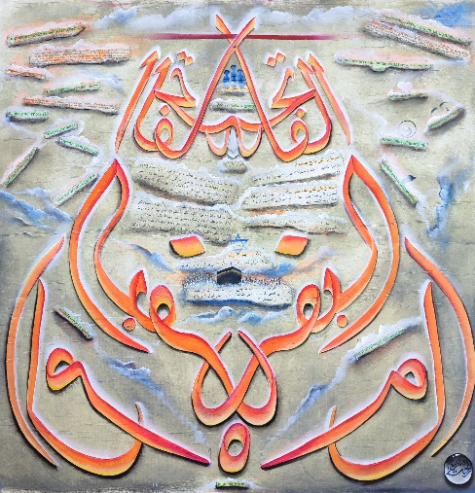
Medium oil
Canva Size 33x33 inches

First juzz of Quran illustration:
The Quran open with Surat al-Fatiha.
There are only two surahs on the 1st juz. The surahs in juz 1 are Surah Al Fatiha and part of surah Al Baqarah, the longest chapter of the Quran. The name of first juzz is Alif Laam Meem. , following are the lessons we’ve learned from Juz 1 so far:

PARA 2/ Juzz 2 Sayaqool:
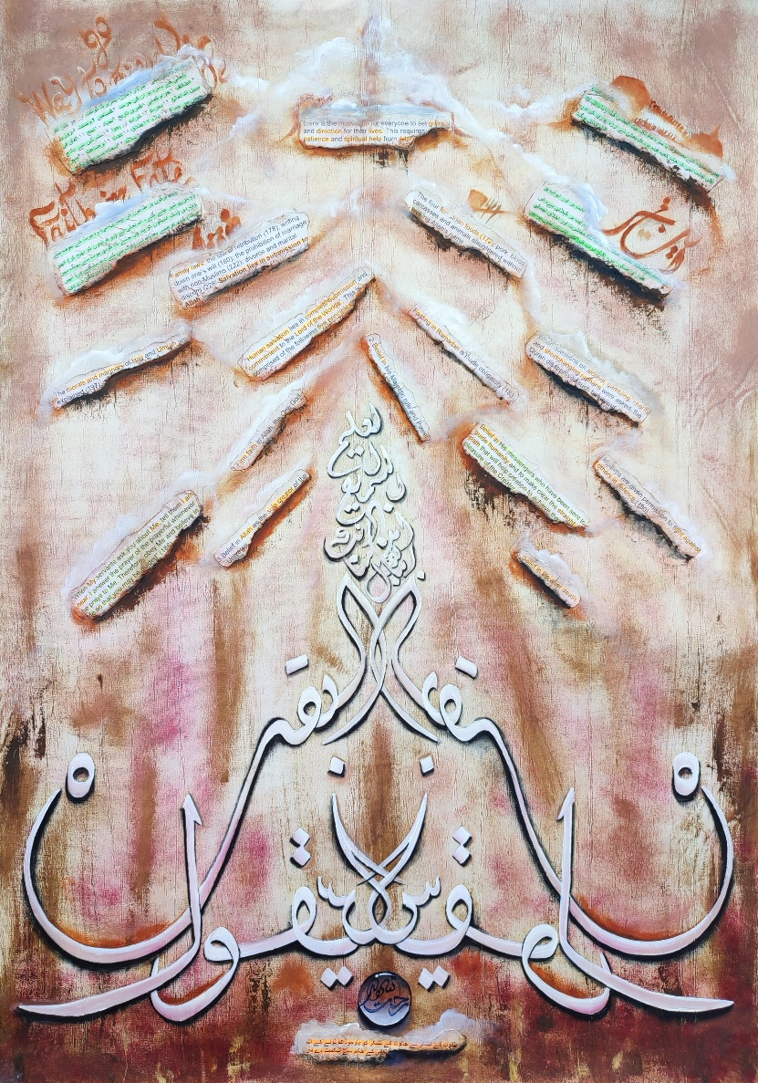
Medium oil
Paper Canvas Size 33x44 inches

Juzz 2 Illustration:
- There are 4 main things in this chapter.
- Delivering Qibla.
- ۔آیت بر اور ابوابِ بر.
- The story of plague.
- Tale of Talut.
- Lessons from this juz.
- There is the motivation for everyone to set goals and direction for their lives. This requires patience and spiritual help from Allah.
- The four forbidden foods (172); pork, blood, carcasses and animals slaughtered without invoking Allah’s name.
- When questions on alcohol, gambling, charity and shortchanging orphans were asked, the Quran disapproved such behaviour.
- Fasting in Ramadan is made obligatory (183).
- The morals and manners of Hajj and Umrah are explained (197).
- Family laws; the law of retribution (178); writing down one’s will (180); the prohibition of marriage with non-Muslims (222); divorce and marital discord (228–Salvation lies in submission to Allah.
- Family laws; the law of retribution (178); writing down one’s will (180); the prohibition of marriage with non-Muslims (222); divorce and marital discord (228–Salvation lies in submission to Allah.
- “Human salvation lies in complete submission and commitment to the Lord of the Worlds”. This is comprised of the following five principles:

- Firm faith in Allah, the One God.
- Belief in his Majestic rule and Power.
- Belief in Allah as the sole creator of the Universe.
- Belief in Allah as the sole creator of the Universe.
- Belief in life after death.

PARA 3 TILKAR RASOOL JUZZ 3:

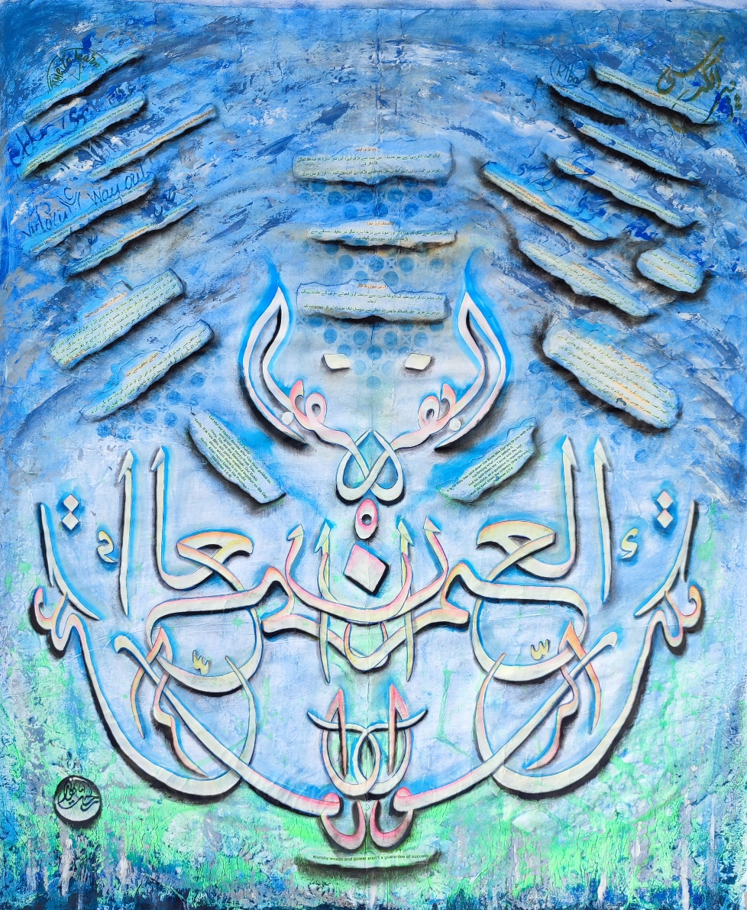
Medium water paint+ oil +acrylic
Paper Canvas Size 34x41 inches

ILLUSTRATION:
- This Juzz has two parts:
- The rest of Surah Baqarah.
- The beginning of Surah Al-Imran.
- (Part One) The remainder of Surah Al-Baqarah contains three things:
- Two major verses 2. Mention of two prophets 3. Charity and usury
- What can we learn from this Juz?
- The greatest verse in the Qur’an: Ayat ul-Kursi, study it, memorize it and make sure you understand it;
- That riba’ is war against Allah and His Messenger;
- That the Qur’an is the criterion between truth and falsehood and Allah will only accept Islam as the true religion;
- The story of Maryam’s (Mary) mother shows how a righteous, sincere intention has a good effect on one’s child;
- Musa (Moses), Esa, Muhammad (peace be upon them all) were all upon the belief of Tawhid (Divine Unity) and warned against shirk (polytheism).
- We are taught an important lesson when it comes to criticizing society or a nation: That it is wrong to generalize.
- Having appealed to the Christians in the preceding part of Aal-e-‘Imran and the Jews in the previous chapter, Allah now directs His verses to the Muslim community.
- This begins with a call for the Muslim community to remain united, holding fast to the rope of Allah. It then addresses the battles of Badr and ‘Uhud, detailing the reasons why Badrwas a victory against all odds and ‘Uhud the opposite.
- Allah concludes by reminding us that His Promise is certain and that we must remain patient and have Taqwa (God Consciousness).
- In this Juz also begins the chapter al-Nisa (Women), named after the numerous references to women and injunctions related to them.
- This chapter is important, as being revealed after the defeat at ‘Uhud it covers some of the inevitable consequences; widows, orphans and the fair distribution of wealth.
- Worldly wealth and power aren’t a guarantee of success.
PARA 4 (LAN TANA LOO):
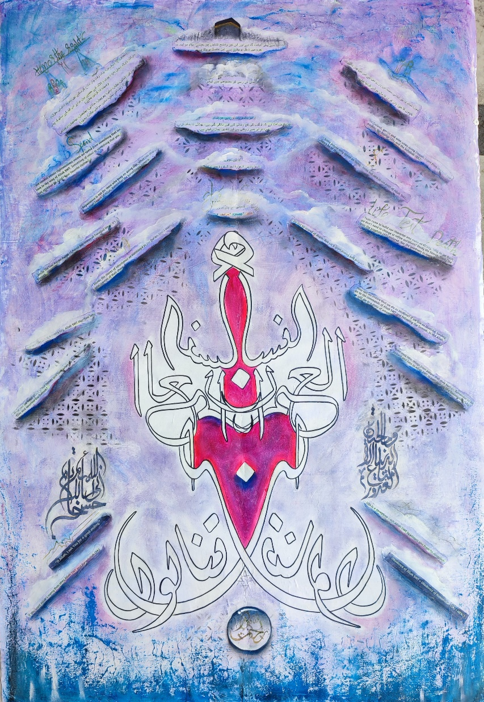
Medium oil+ acrylic
Paper Canvas Size 28x41 inches

ILLUSTATION:
- Summary Fourth Para.
- This juz has two parts:
The rest of Surah Al-Imran.
The beginning of Surah Nisa.
- (Part One) The remaining part of Surah Al-Imran contains five things:
- . Virtues of the Kaaba
- . Reciprocity
- . Amr al-Moruf and Nahi an al-Munkar
- . Three battles
. The four principles of success.

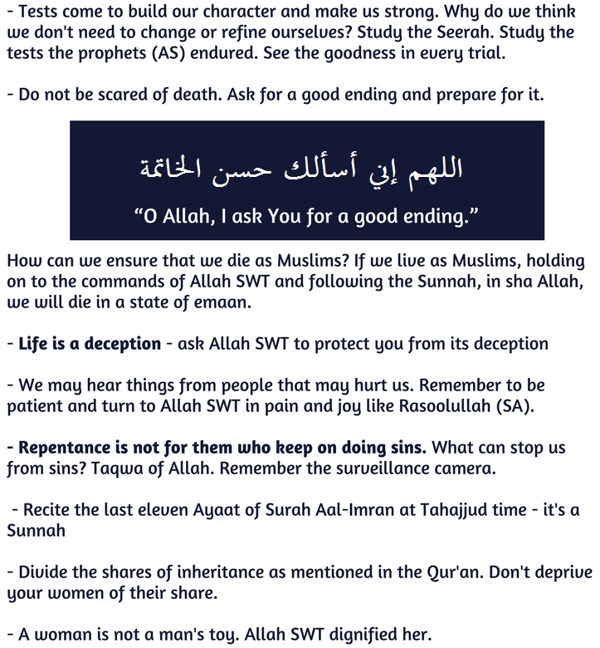


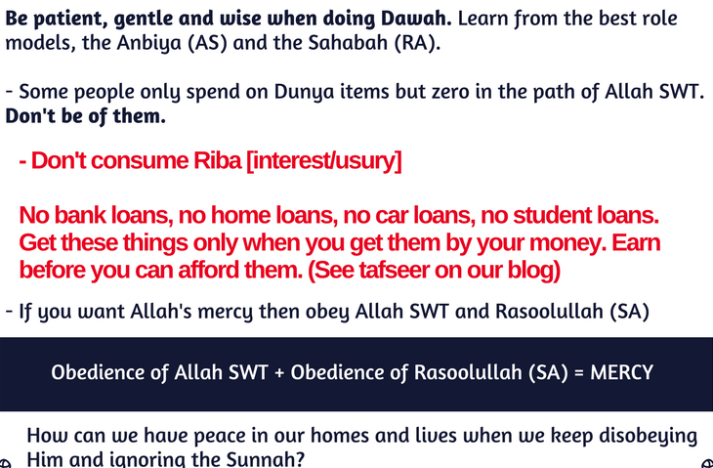

PARA 5 (WAL MUHSANAT):

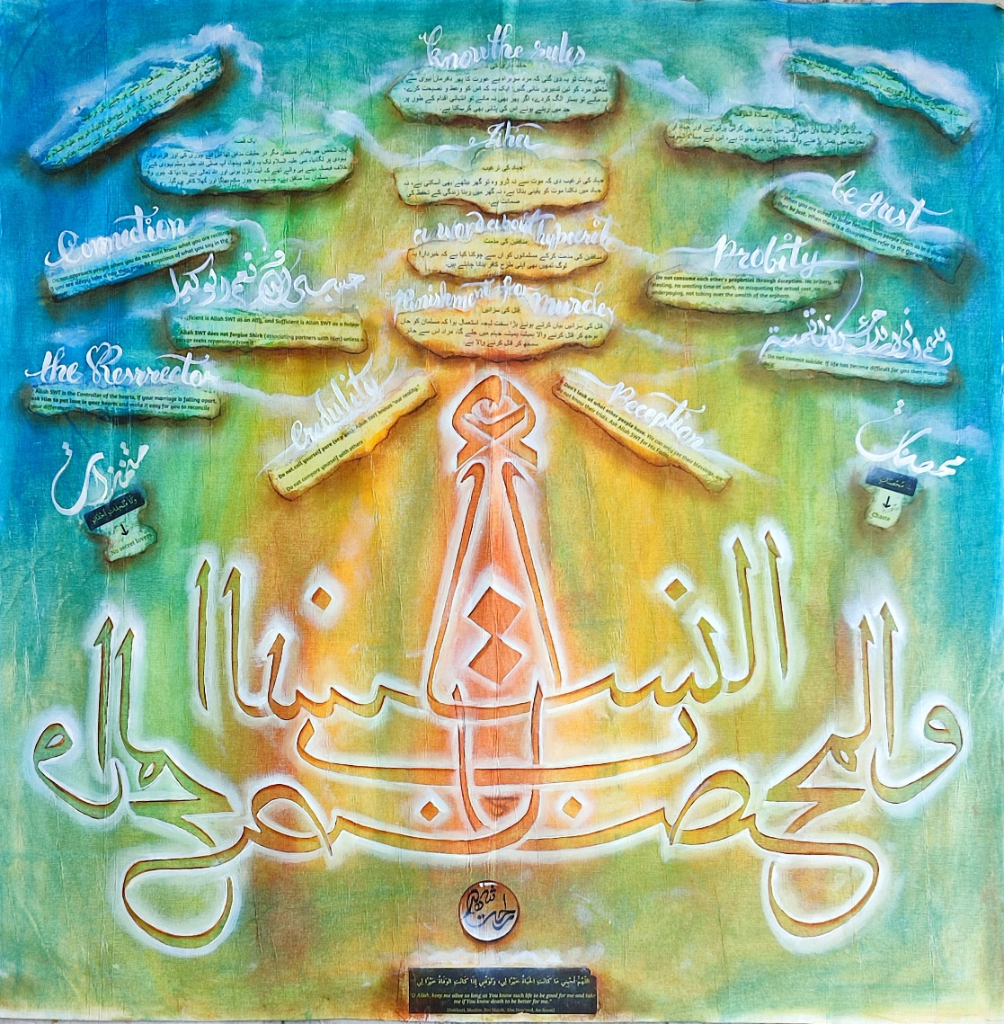
Medium oil
Paper Canvas Size 33x33 inches

ILLUSTRATION:
There are eight things in this para
1. Household measures.
2. Justice and kindness.
3. Motivation for Jihad.
4. Condemnation of hypocrites.
5. Penalties for murder.
6. Hijra and Salat al-Khaf.
7. A story.
8. Encouragement to follow the straight path.
LESSONS:
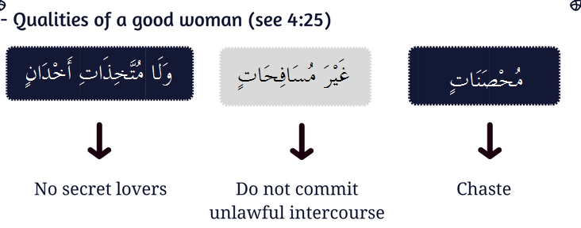

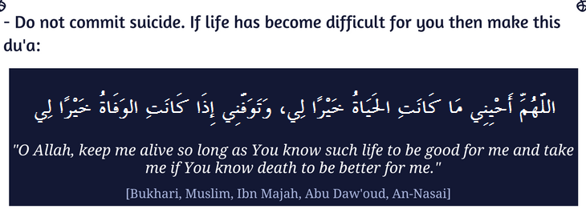



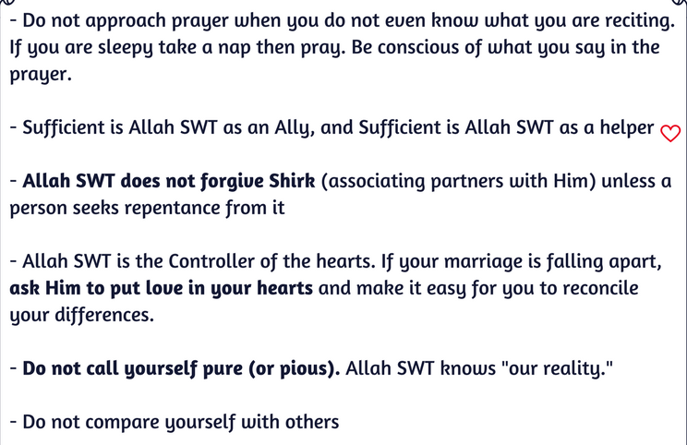

PARA 6 (Ya Yahubbullah):
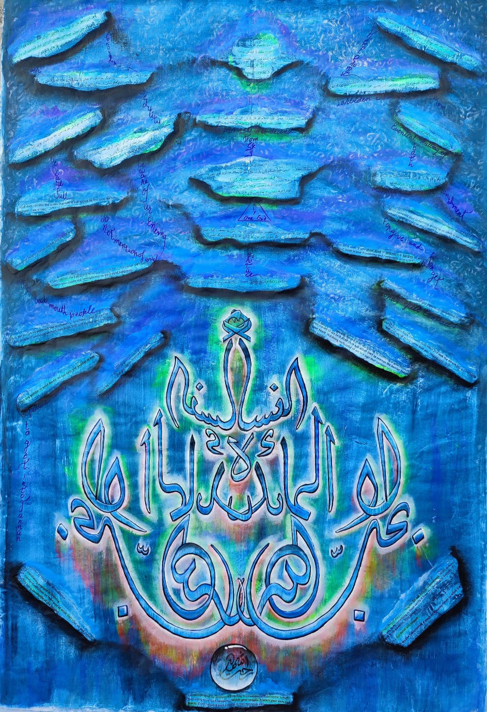
Medium oil+acrylic
Paper Canvas Size 41x28 inches

ILLUSTRATION:
This juz has two parts
1. The rest of Surah Nisa.
2. The opening part of Surah Maida.
(Part One) The rest of Surah Nisa has three things:
1. Condemnation of Jews.
2. Condemnation of Christianity.
3. Inheritance.


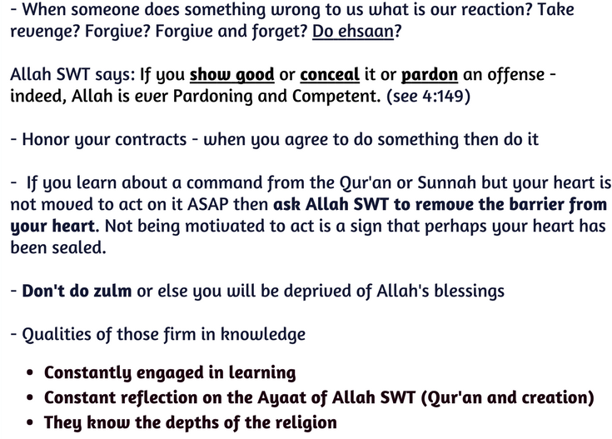


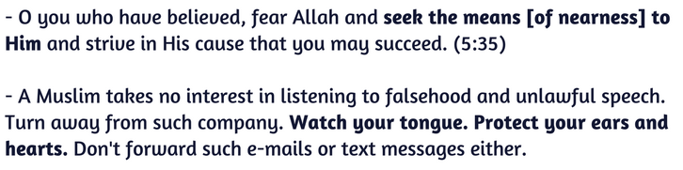

PARA 7 (WA IZA SAMIU):
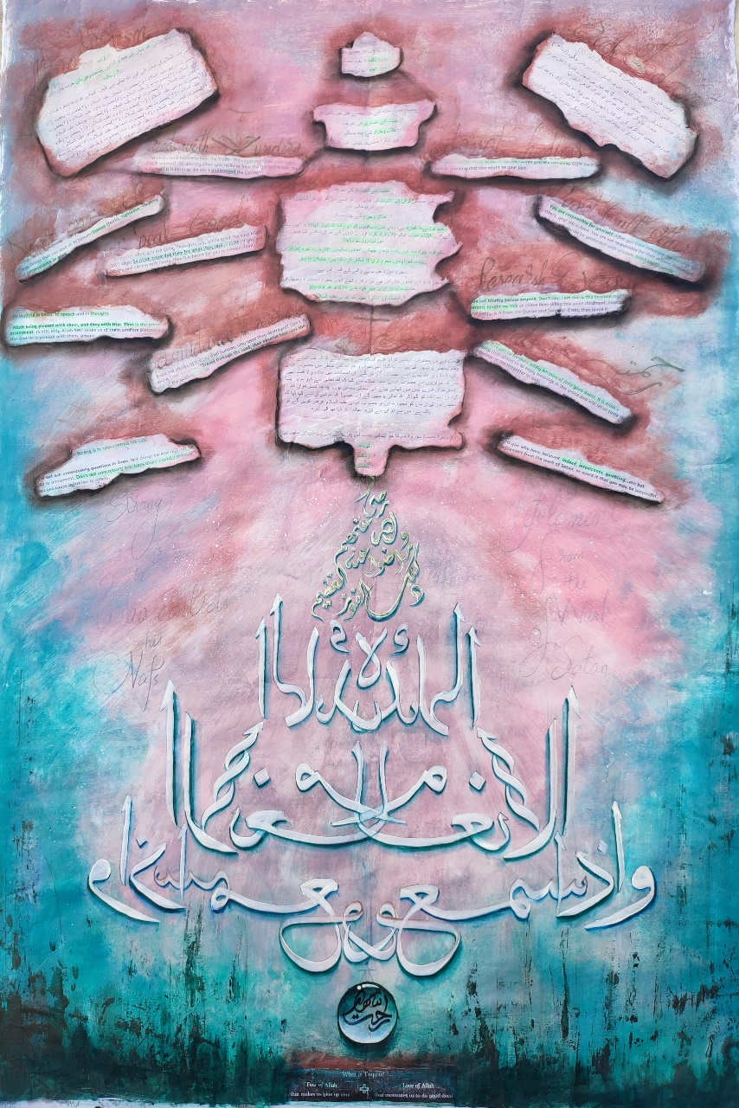
Medium oil +Acrylic
paper canvas size 41x28

ILLUSTRATION:
- The seventh para
- This juz has two parts:
- 1. The remainder of Surah Maida
- 2. The first part of Surah An'am
- (First Part) The remaining part of Surah Al-Maidah contains three things:
- 1. Appreciation of the Christians of
- Abyssinia
- 2. Some problems of Halal and Haram
- 2. Resurrection and remembrance of Hazrat Isa (peace be upon him).

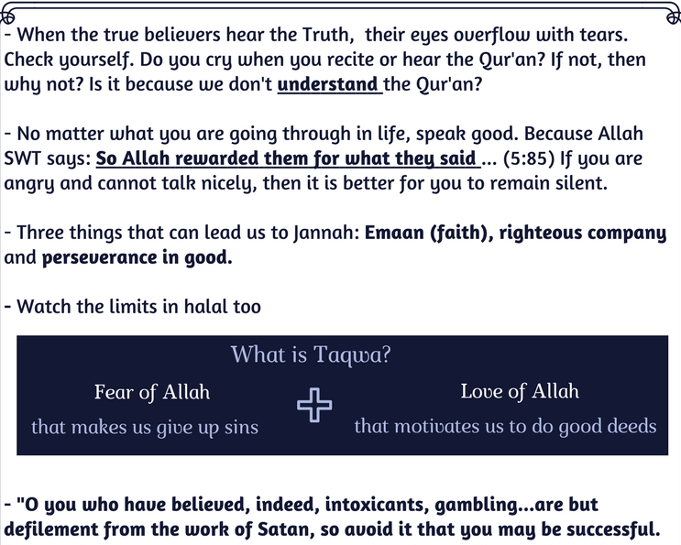

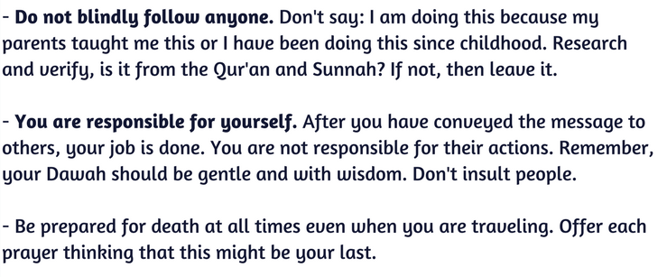

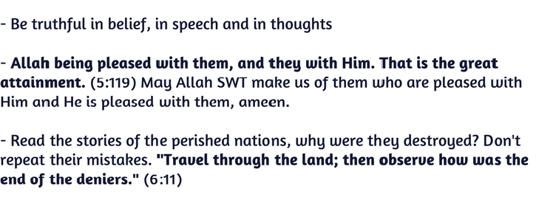



PARA 8 (WA LAU ANNANA)

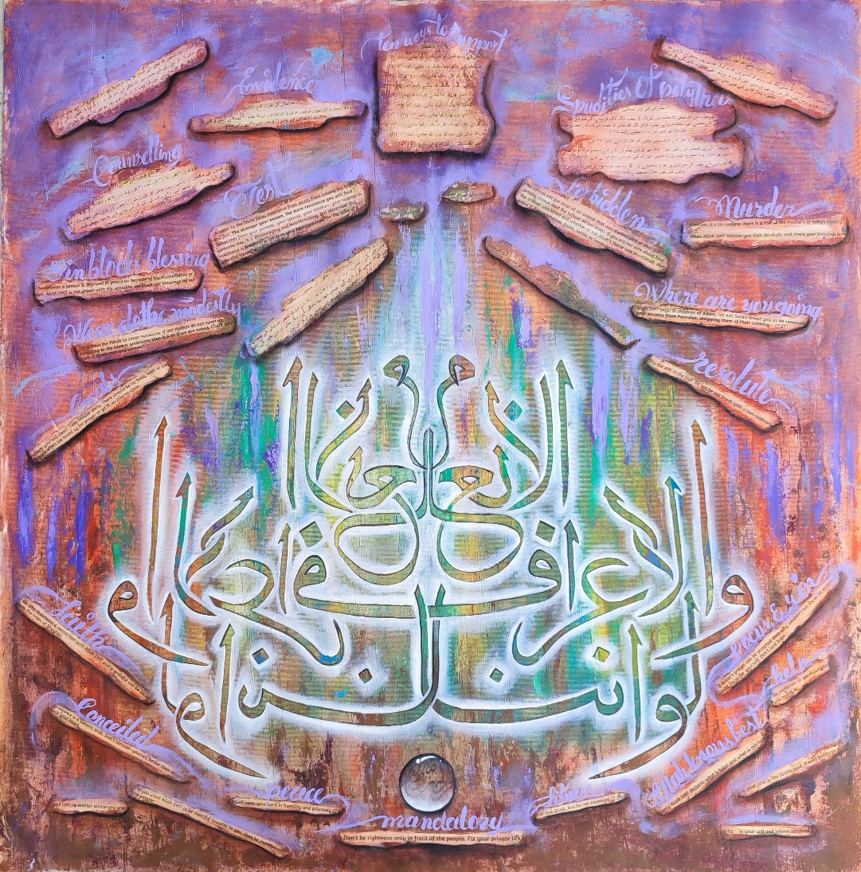
Medium oil
size 33x33

ILLUSTATION JUZZ 8:
This paragraph has two parts:
1. The rest of Surah Inam
2. The opening part of Surah A'raf
(First Part) The remaining part of Surah Inam contains four things:
1. Peace be upon the Prophet (peace be upon him).
2. Four follies of the polytheists
3. Two blessings of Allah Ta'ala
4. The Ten Commandments

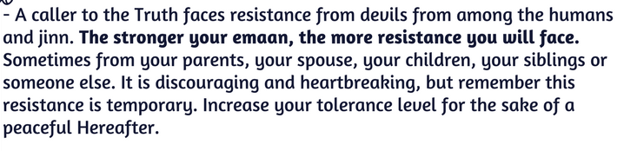

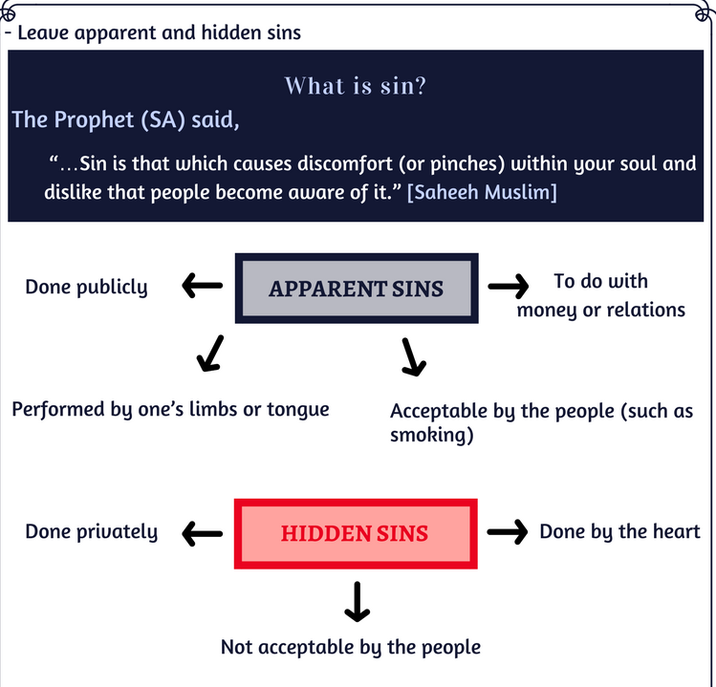



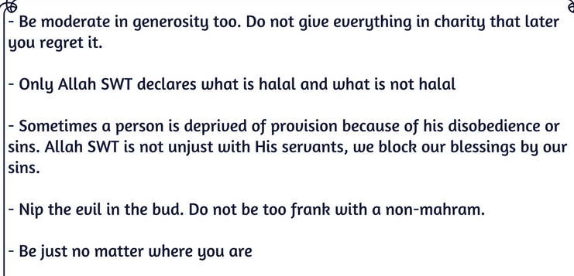
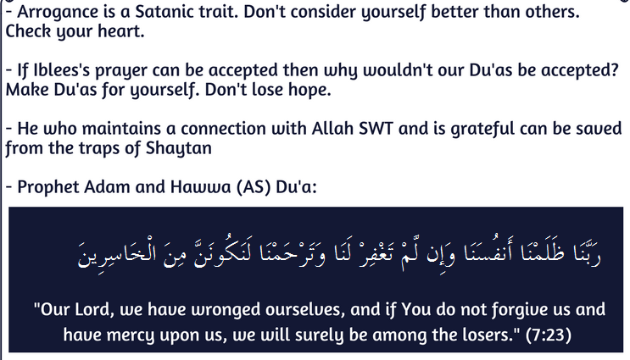
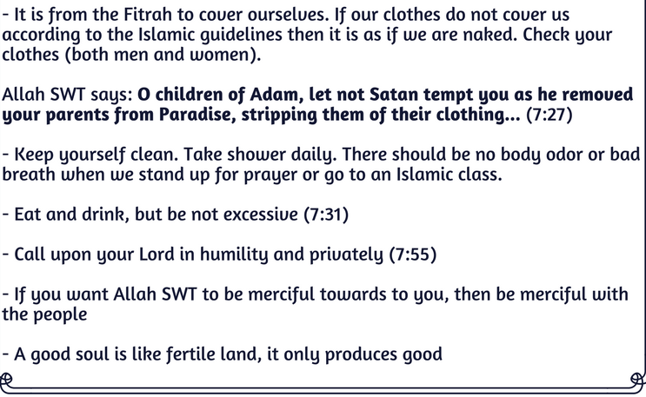

PARA 9 (QALAL MALAO):
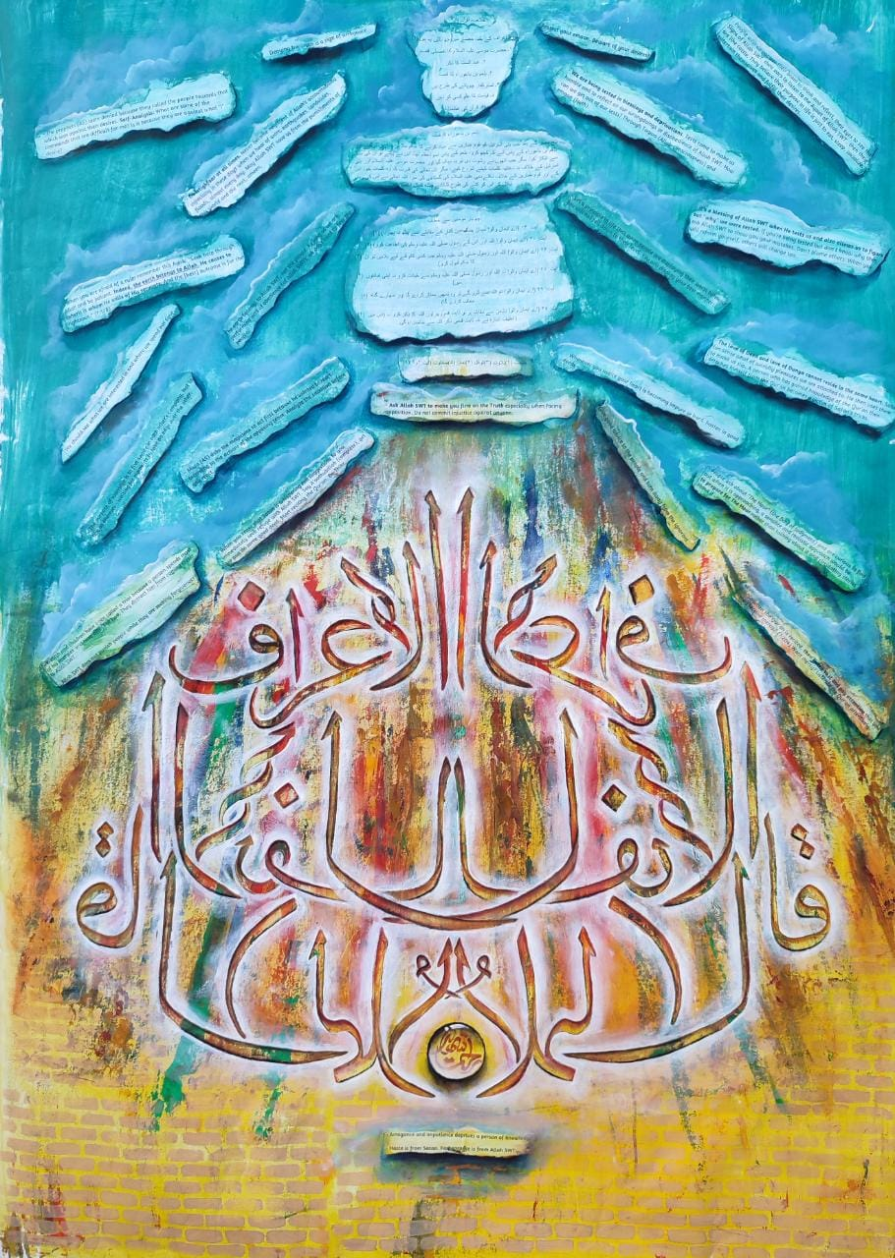
Medium oil+Acrylic
Paper canvas size 41x30

ILLUSTATION:
- Summary Ninth Para .
- This juz has two parts:
- 1. The remainder of Surah A'raf.
- 2. The opening part of Surah Anfal.
- (1) There are six things in the remaining part of Surah A'raf:
- 1. The detailed story of Hazrat Musa (peace be upon him).
- 2. Mention of the era.
- 3. The story of Balaam bin Baawra.
- 4. All disbelievers are like cattle.
- 5. No one knows the Day of Resurrection.
- 6. The Greatness of the Qur'an.

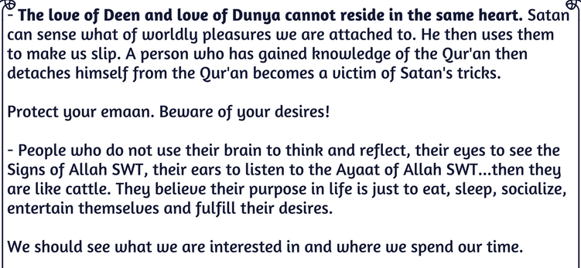
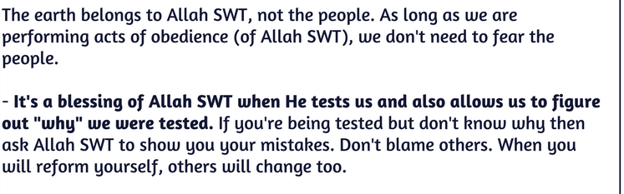
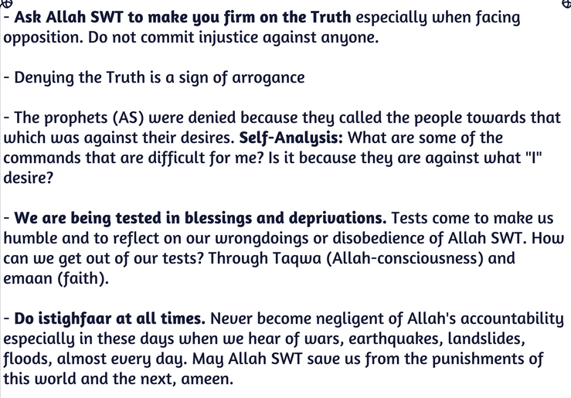

PARA 10 (WA A’ LAMU):
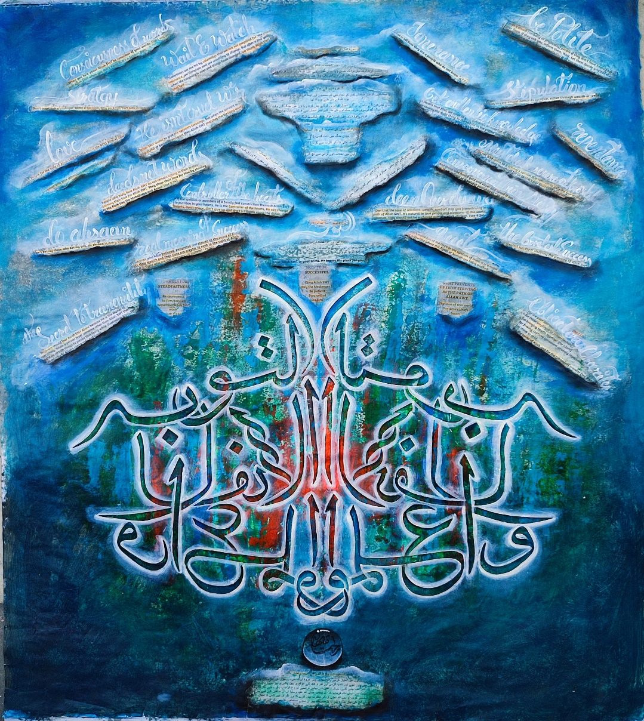
Medium oil+Acrylic
Paper Canvas Size 34x41 inches

ILLUSTRATION:
- This para has two parts:
- 1. The remainder of Surah Anfal.
- 2. The opening part of Surah Towbah.
- There are five things in the remaining part of Surah Anfal:
- 1. Order of booty.
- 2. Circumstances of the Battle of Badr.
- 3. Four reasons for Allah's help.
- 4. War Instructions.
- Virtues of Hijra and Nusrat.

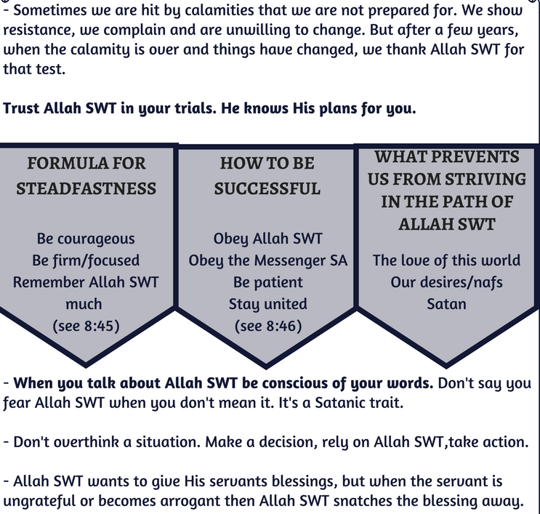

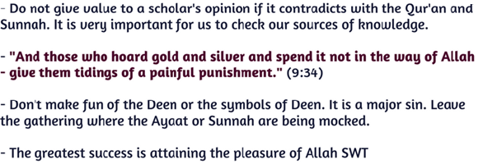
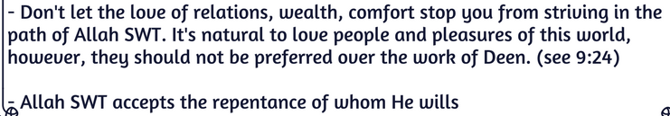

PARA 11( YA TA ZAROON):
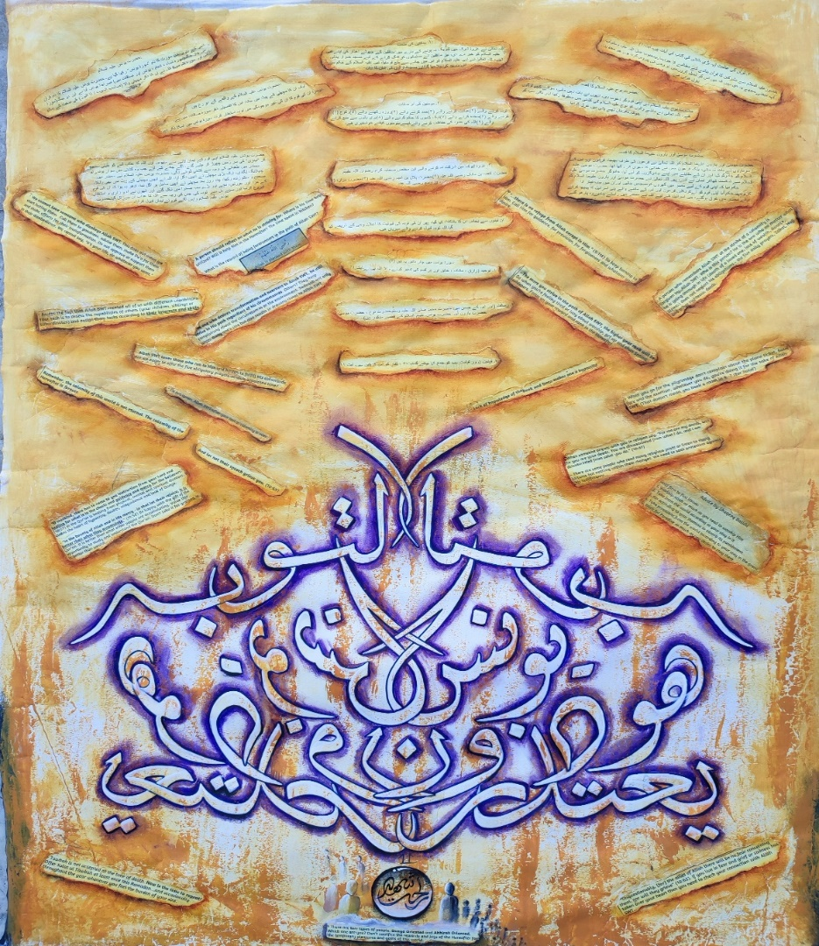
Medium oil
Paper Canvas Size 41x30

ILLUSTRATION:
- Summary Eleventh Para.
- This para has two parts:
- 1. The remainder of Surah Towbah.
- 2. Surah Yunus complete.
- (1) There are three things in the remaining part of Surah Towbah:
- 1. Condemnation of hypocrites.
- 2. Nine attributes of believers.
- 3. Summary of mention of three sincere Companions who did not participate in the Battle of Tabuk.
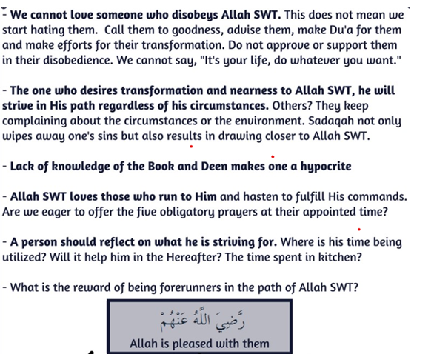
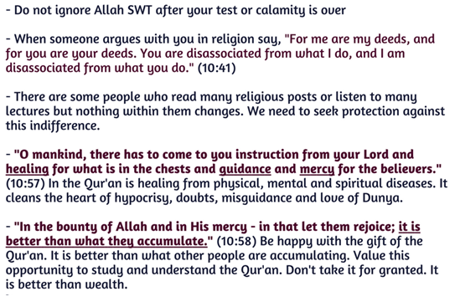

PARA 12 (Wa Mamin Daabat):
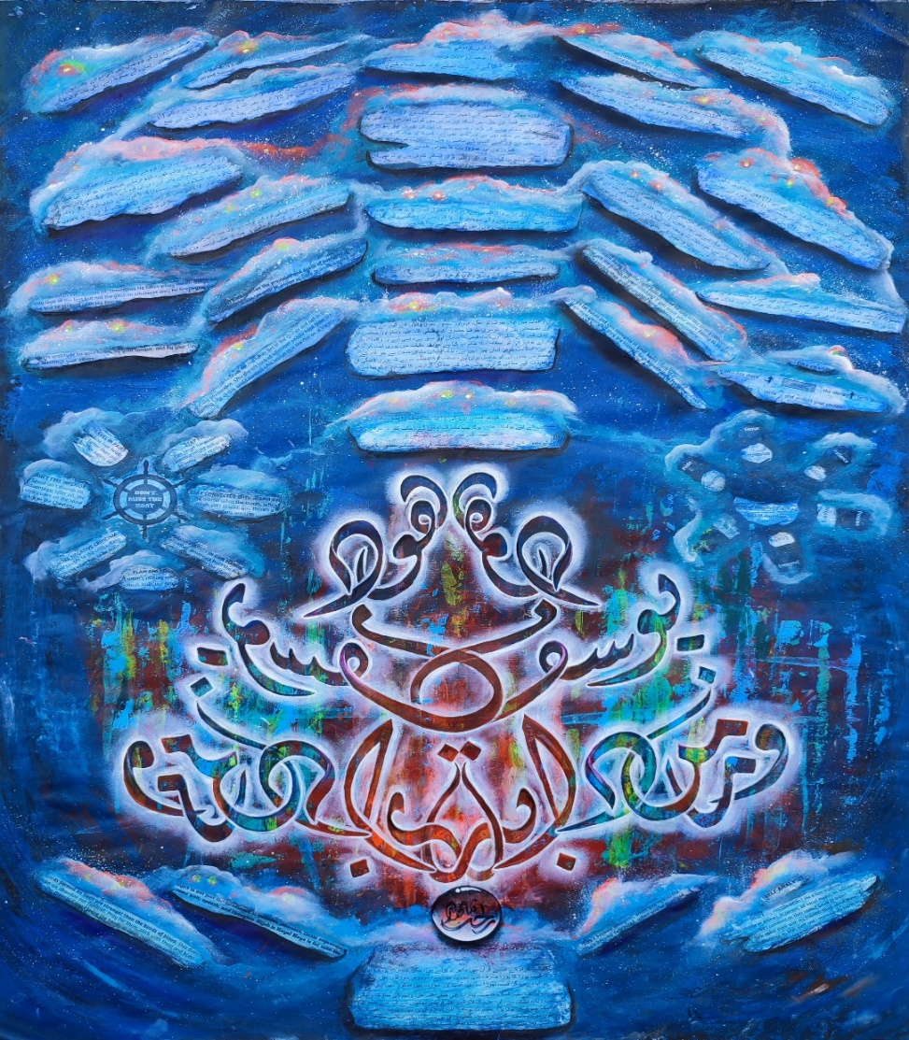
Medium oil+Acrylic
Paper Canvas Size 41x30

ILLUSTRATION:
- Summary Twelfth Para.
- This para has two parts:
- 1. Surah Hud complete (its first five verses are in the eleventh verse).
- 2. The opening part of Surah Yusuf.
- (1) There are four things in Surah Hud:
- 1. The greatness of the Holy Quran.
- 2. Tawheed and Arguments of Tawheed.
- 3. Prophethood and the events of the seven Prophets to confirm it.
- 4. Mention of the Resurrection.


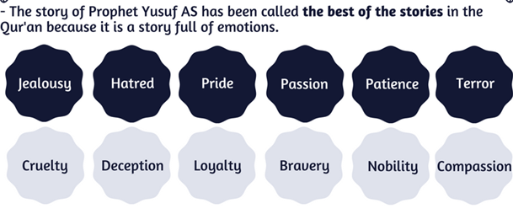
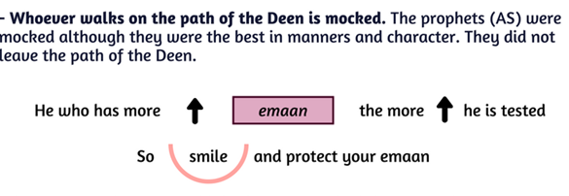

Self Analysis:
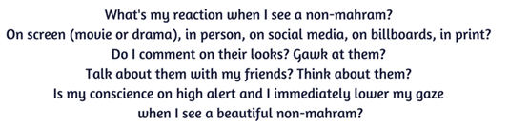

PARA 13 (WA MA UBIROO):
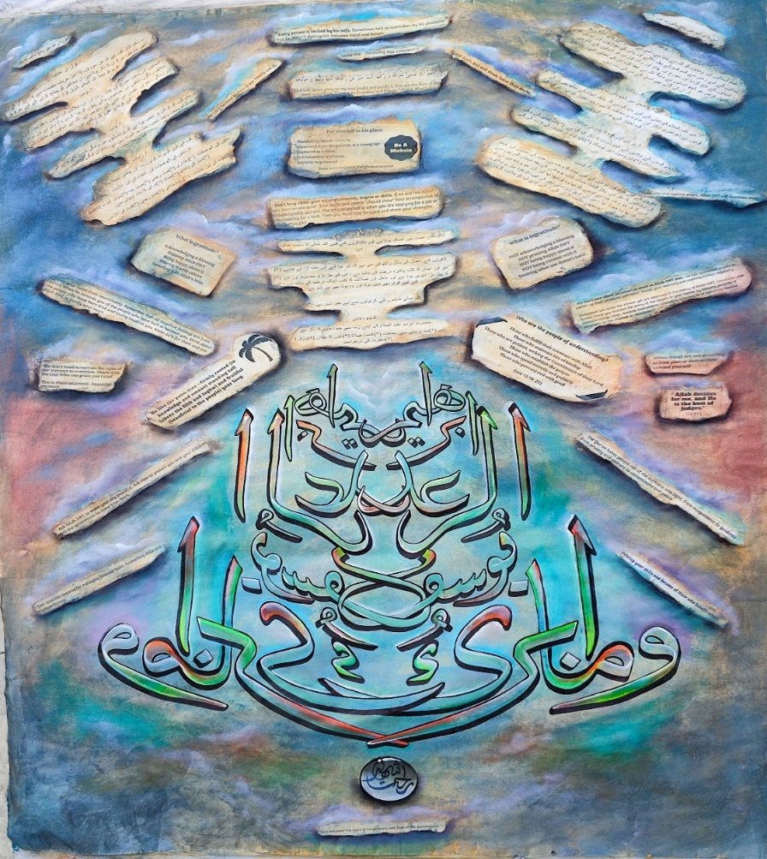
Medium oil+acrylic
Paper Canvas Size 41x29

ILLUSTRATION:
There are 3 parts in the para.
- The reminder of surah yusaf.
- Surah Raad complete.
- Surah Ibrahim complete.
The remainder of surah yusaf:
Its detail is mentioned in the previous paragaragh.
There are 5 things in surah Raad:
- The authenticity of Quran.
- Monotheism.
- Day of judgement.
- Mission.
- Eight attributes of Mutaqeen and three signs of Ashqiyyah.

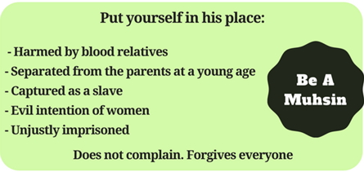

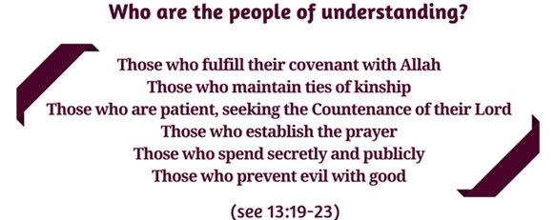

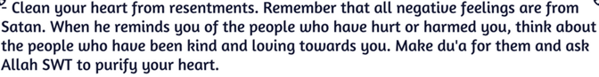

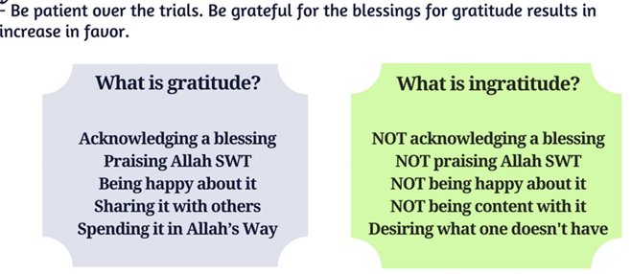

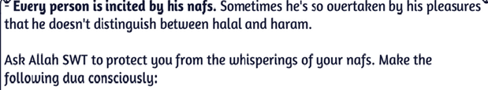





PARA 14 (Rab Ma):

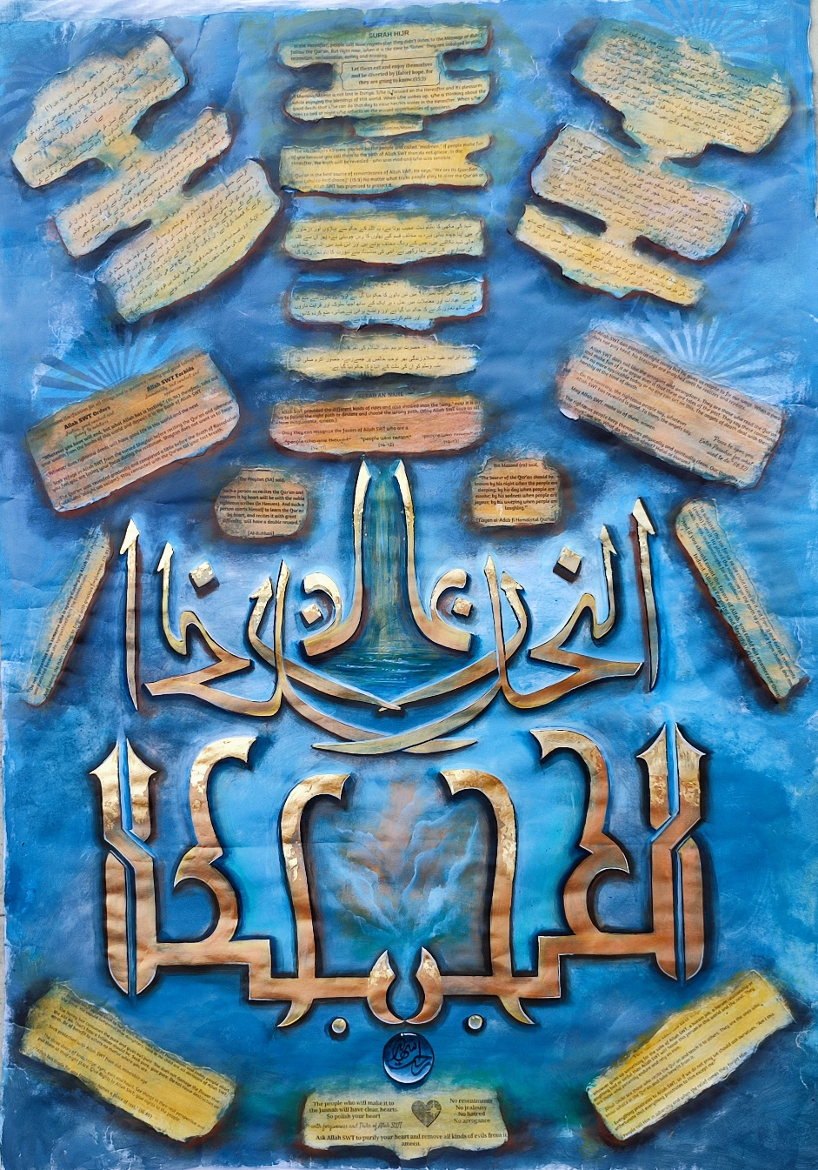
Medium oil+ acrylic
Paper Canvas Size 41x29

ILLUSTRATION:
- 1. Surah Hajar complete.
- 2. Surah Nahl complete.
- (1) There are four things in Surah Hajr:
- 1. Desire of the infidels (In the Hereafter, when the infidels see the Muslims enjoying themselves and themselves in torment, they will wish that they too would become Muslims).
- 2. Protection of the Qur'an (Allah has taken responsibility for the protection of the Qur'an until the Day of Resurrection).
- 3. The creation of man (Allah created man from semen, made a mosque for angels, Satan was rejected, he swore to mislead people (except the sincere) until the Day of Resurrection).

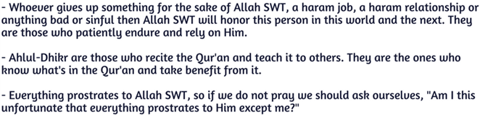

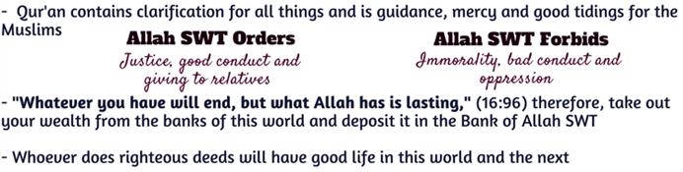
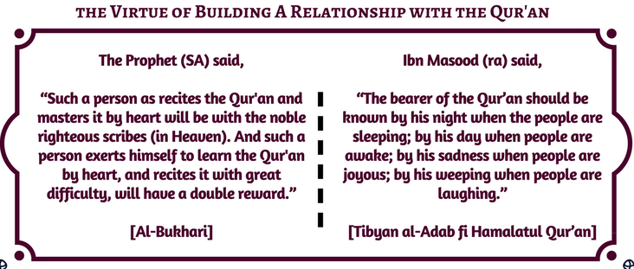
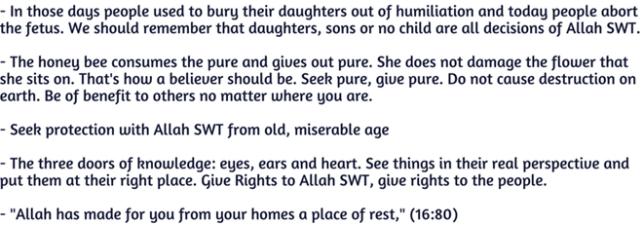

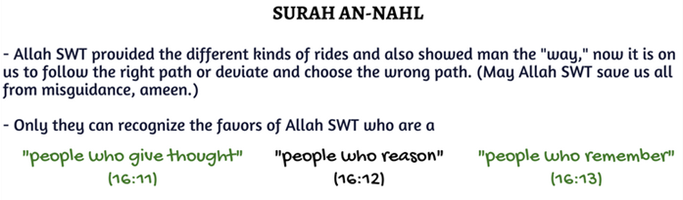



PARA 15 (Subhan allahzi):
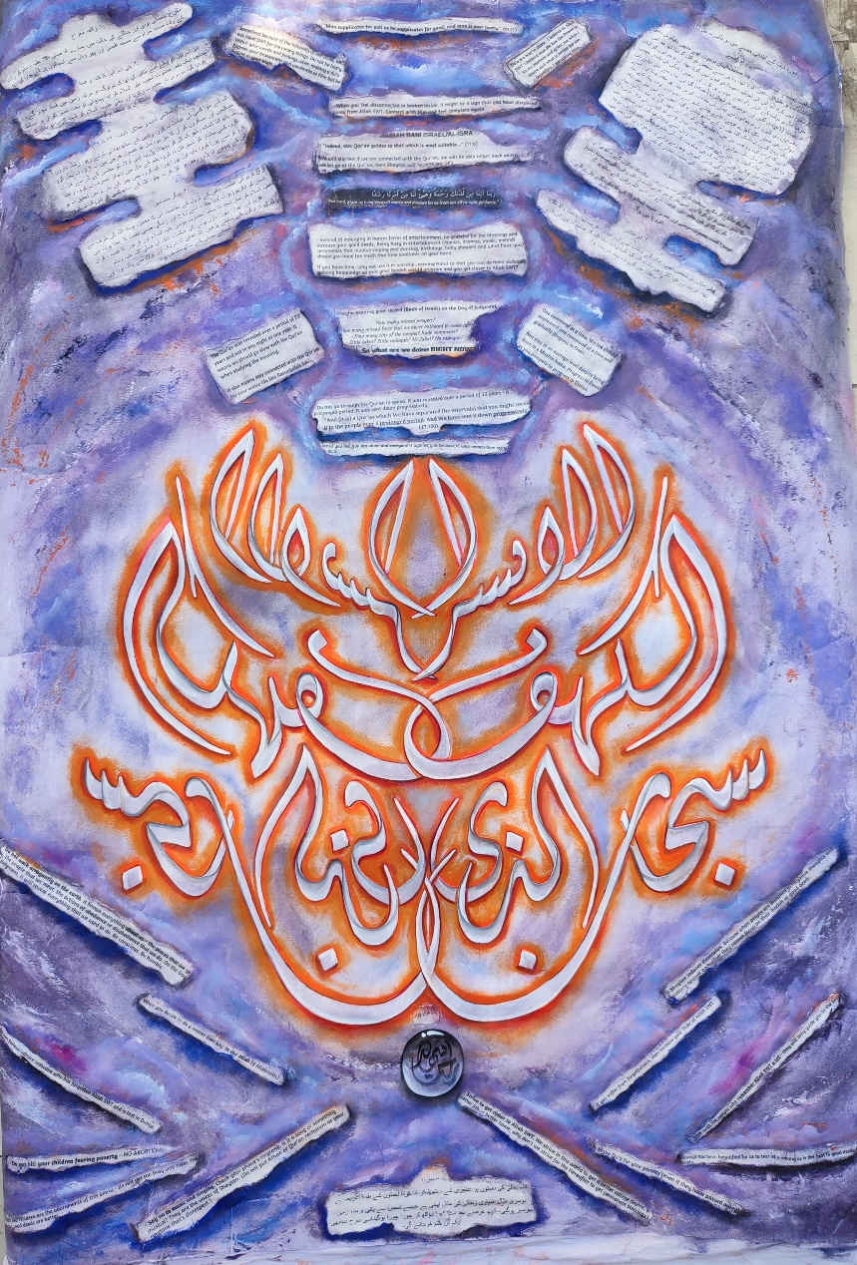
Medium oil+acrylic
Paper Canvas Size 41x29

ILLUSTRATION:
- This juz has two parts:
- 1. Surah Bani Israel complete.
- 2. Most of Surah Kahf.
- (1) There are four things in Surah Bani Israel:
- 1. Ascension event.
- 2. The temptation and corruption of the Israelites.
- 3. Islamic ethics.

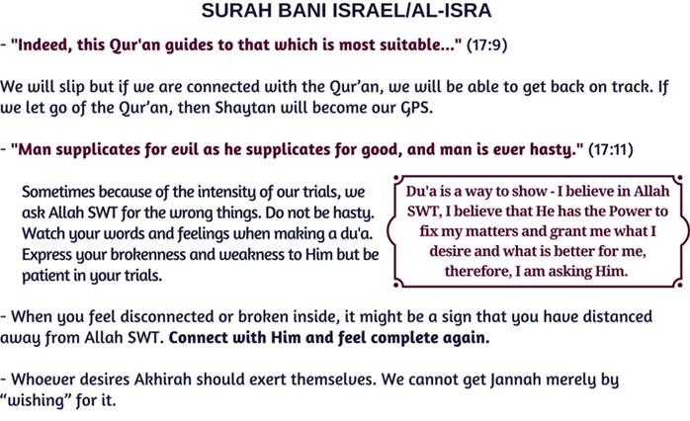
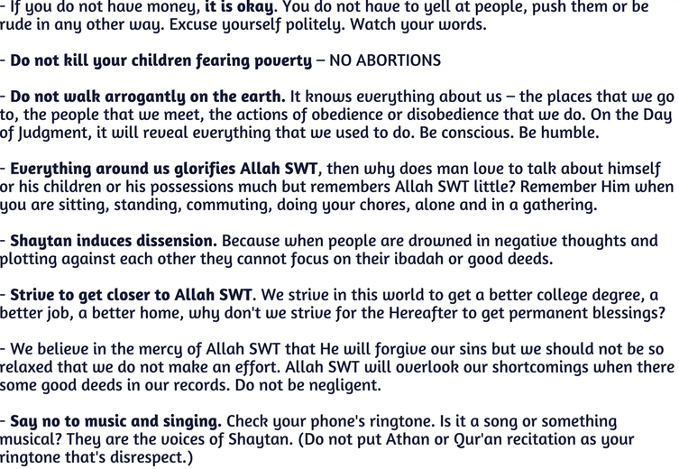

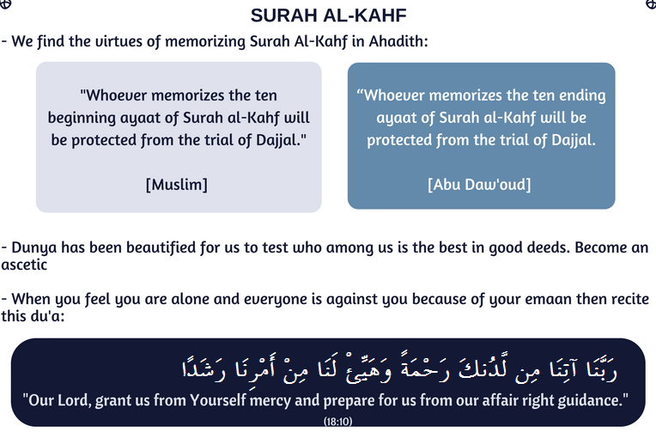

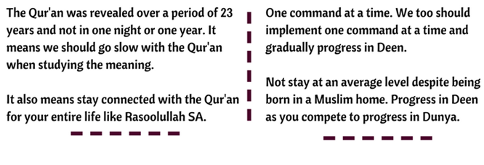

Special Offer:
I will give 10% of on first purchase.

